FIELD TRIP TO NATURE PARK

Dear Parents and Guardians,

This week in class we are learning about ducks. On Wednesday, we will have a short lesson in class on where ducks live and what they eat. Then we will be taking the bus and going to the Nature Park. Once we arrive at the park, we will walk along the path and observe the ponds and the ducks. Once we arrive at a destination with a good amount of ducks we will feed them.

Any parents that would like to volunteer to come along are welcome and much appreciated; also if any parents would like to send their child with some bread for the ducks that would be appreciated as well.

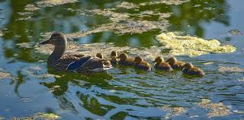
Figure 1Image Source: https://www.google.com/search?as_st=y&tbm=isch&hl=en&as_q=ducks+in+a+pond&as_epq=&as_oq=&as_eq=&cr=&as_sitesearch=&safe=images&tbs=sur:fm#imgrc=UBS1vDOkWGePaM:

“I hereby give permission

for to participate in this fieldtrip to the Nature Park and to ride on the bus.

I would like to volunteer to come along. (Check the box if you would like to volunteer).

