Boy Scout Flag Fundraiser

Every year the scouts go on a scout camp that we have to pay for. This can end up costing us a lot of money, so we try to find ways to earn money to help us get to camp. Scout camp is a great opportunity for us to grow physically, mentally, spiritually, and socially. We are offering flag services for various holidays throughout the year. We will set up flags in your yard for each of the holidays listed below.

Holidays included are:
- Memorial Day
- Flag Day
- Independence Day
- Labor Day
- Election Day
- Inauguration Day

Help us get
to camp!

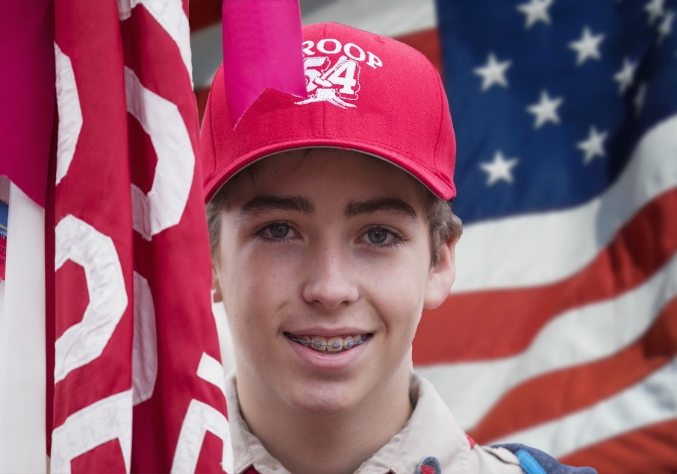
Prices
1 year | $25
Per holidays | $5

Any donations are greatly appreciated!

